**WORLD UNIVERSITIES RANKING ANALYSIS**

*Prepared in the partial fulfillment of the Summer Internship Program on Data Analysis*

AT



*Under the guidance of*

***Mrs. Meenakshi, APSSDC***

***Mrs. Narmada Mani, APSSDC***

*Submitted by*

Dandina Rupa Devi Nagamani - 21X41A4212

Kolli Lavanya Sri Venkata Sarika - 21X41A4226

Singam Navya Sri - 21X41A4252

Chalapathi Teja Sri- 21X41A4211

## **ACKNOWLEDGEMENT**

## 

I would like to express my heartfelt gratitude to all those who have contributed to the

successful completion of my summer internship project at **Andhra Pradesh Skill**

**Development Corporation (APSSDC)**. This opportunity has been an enriching and

transformative experience for me, and I am truly thankful for the support, guidance, and

encouragement I have received along the way.

First and foremost, I extend my sincere regards to Mrs Narmada Mani and Mrs Meenakshi,

my supervisors and mentors, for providing me with valuable insights, constant

guidance, and unwavering support throughout the duration of the internship. Their expertise

and encouragement have been instrumental in shaping the direction of this project.

I would like to thank the entire team at **Andhra Pradesh Skill Development Corporation**

**(APSSDC)** for fostering a collaborative and innovative environment. The camaraderie,

knowledge sharing, and feedback I received from my colleagues significantly contributed to

the development and success of this project.

In conclusion, I am honoured to have been a part of this internship program, and I look

forward to leveraging the skills and knowledge gained to contribute positively to future

endeavours.

Thank you.

Sincerely,

Dandina Rupa Devi Nagamani - 21X41A4212

Kolli Lavanya Sri Venkata Sarika - 21X41A4226

Singam Navya Sri - 21X41A4252

Chalapathi Teja Sri- 21X41A4211

**ABSTRACT**

Over the last years, the global university rankings appeared in order to measure the performances of higher education institutions from all over the word after some pre-established indicators. The rankings make it possible to evaluate complex information according to various combinations of various factors.

I described and analyzed three of the most known, influential and widely observed international university rankings, in order to identify the similitudes and especially the differences between them regarding the methodology, criteria and weights, top universities, research and educational process or the global outlook, using the public and available information from their web-sites.

Also, I want to see the impact of these rankings and how they influence the stakeholders, which are winners of each of these global university rankings, from want countries or regions. Global university rankings tend to focus more on the research area and less on the teaching and learning environment.

After the results of these rankings and others, all universities, whether small or large, can improve practices that will make them stronger. For contemporary society it is also important for a university to be able to innovate and help industry and businesses with consultancy and innovations.

## 

## **TABLE OF CONTENTS**

### S.No Content

1. Introduction

2. System requirements

3. Architecture of the analysis

4. Methodology

5. Goals of the analysis

6. Analysis/Interpretation

7. Codes of analysis

8. Results

9. Conclusion and Reference links

**INTRODUCTION**

A ranking represents a relationship between a set of items such that, for any two items,the first is either “ranked higher than”, “ranked lower than” or “ranked equal to” the second. In mathematics, this is known as a weak order or total preorder of objects. It is not necessarily a total order of objects because two different objects can have the same rankingA ranking represents a relationship between a set of items such that, for any two items,the first is either “ranked higher than”, “ranked lower than” or “ranked equal to” the second. In mathematics, this is known as a weak order or total preorder of objects. It is not necessarily a total order of objects because two different objects can have the same ranking.

In the current globalized economy, global university rankings are used to measure their global competitiveness, being simultaneously criticised and lauded. Most of the university rankings have been conducted by magazines, newspapers, websites, governments, or academics. Therankings cover at this moment only a small percentage of approx. 2-3% of the total of universities.

**System Requirements**

**Software Specifications:**

* Language Used: Python
* Operating System: Windows 11

**Hardware Specifications:**

* Hard Disk: 512 GB
* Processor: Intel(R) Core(TM)
* Interpreter: Jupyter Notebook(Anaconda)

**Architecture Of The Analysis**

* Importing python libraries for analysis
* Finding and reading the dataset
* Getting a feel of dataset
* Data cleaning
* Grouping the data using different aspects of variables
* Sorting the dataset by considering the most and least ranking universities(No.of students,no.of students assigned to the staff,Female male ratio…..)
* Aggregation Of numeric columns.
* Data Visualization: Visual plotting like histogram, barplot,pie charts on various numeric columns….etc.
* Relation between numeric columns using correlation of heatmaps

**METHODOLOGY**

Define Objectives and Research Questions: Defining the research Objective will guide the entire analysis process.

Data Collection: To perform the analysis, you’ll need data on World Universities Ranking such as Ranks,Number of students,Number of students per staff,International students,Female-Male ratio etc..

**GOALS OF THE ANALYSIS**

To determine :

* How many universities have greater than 10000 students ?
* What are the top 10 universities based on rank?
* What are the Universities that contain the maximum rate of international students?
* Print the number of universities based on location?
* Finding the maximum and minimum number of students' university records in the dataset ?
* Grouping the Location column and getting United States Universities records.
* By sorting the dataset, getting the university records based on the number of students.
* How many universities have greater than 1000 students ?
* How many universities have less than 1000 students ?
* How many universities in India using bar plots?
* Visualizing the different columns using a 3D scatter plot.
* What statistical metrics are computed for the columns 'number of students',

‘number of students per staff’ in the dataset.

* Finding strategies like mean, var, median, min ,max of the numerical columns.
* Using Color palette visualize the number of students per staff and universities by importing the seaborn library.
* Visualizing the number of students using histograms.
* How many universities in the United States using bar plots?
* Creating correlation graph between number of students and number of students per staff using heatmaps.
* Visualize the female:male ratio based on universities in the dataset using scatter plot.

**ANALYSIS/INTERPRETATION**

* Analyzed the World universities ranking data to understand the rank patterns.
* We analyzed a dataset that contains information about Ranks of Global Universities in 2023. It contains 2345 universities.
* Analyzed top 10 universities based on rank.
* Analyzed Universities that contain the maximum rate of international students.
* Analyzed Number of universities based on location.
* Analyzed the university records based on the number of students.
* Analyzed statistical methods(mean,median,variance,min,max).
* Analysed the different columns using a 3D scatter plot.
* Analyzed the Universities in the United States using bar plots
* Analysed the correlation graph between number of students and number of students per staff using heatmaps.
* Analysed the number of students using histograms.
* Analysed the female:male ratio based on universities in the dataset using scatter plots.
* Analysed the number of students per staff and universities by importing the seaborn library using colour palette.
* Analyzed the Universities in the United States using bar plots.
* Analysed the universities have greater than 1000 students.

**CODES OF ANALYSIS** 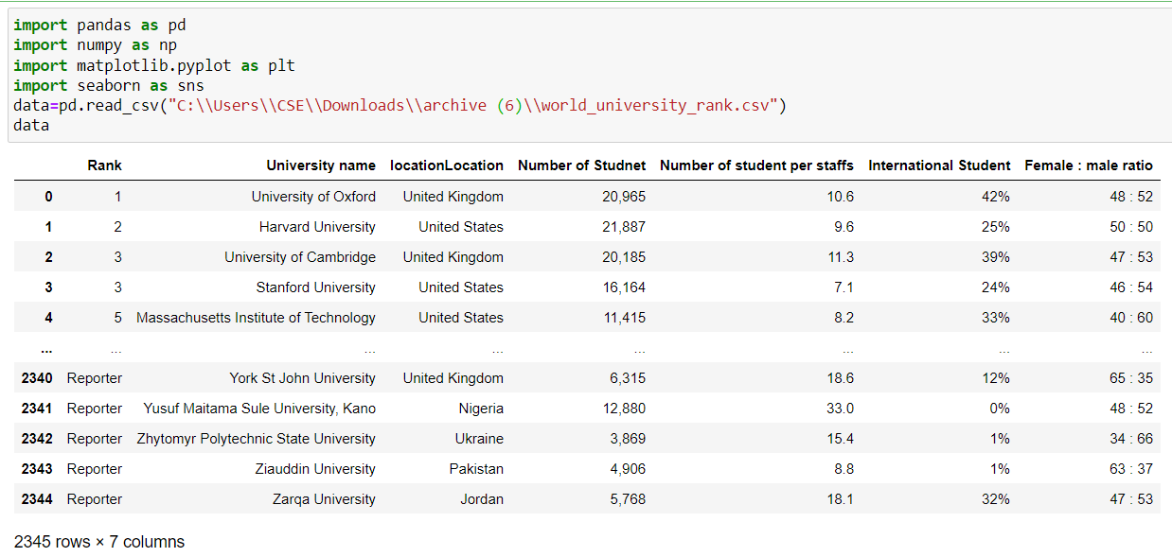

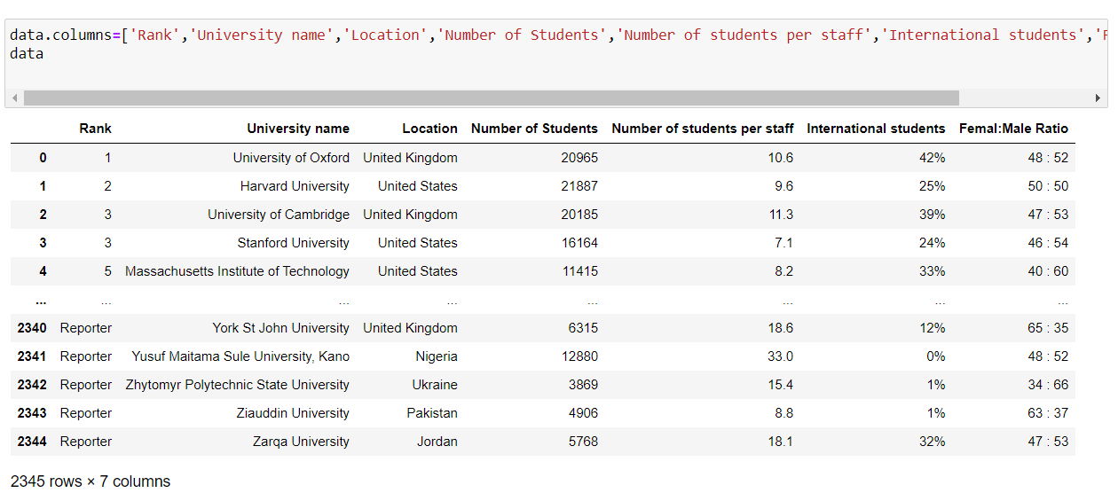

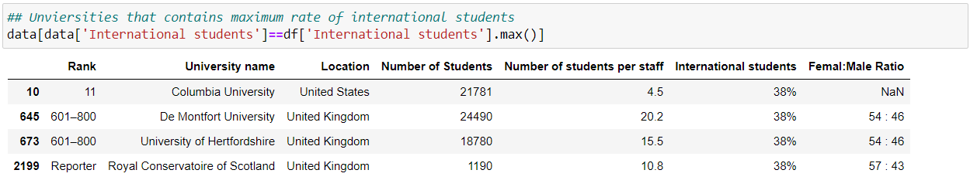

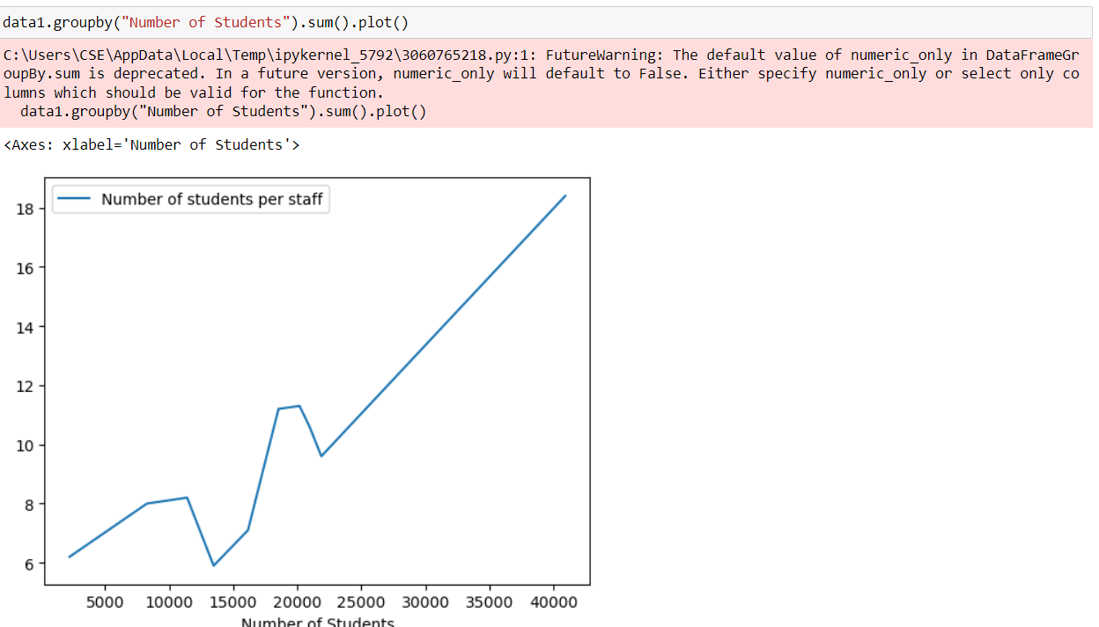

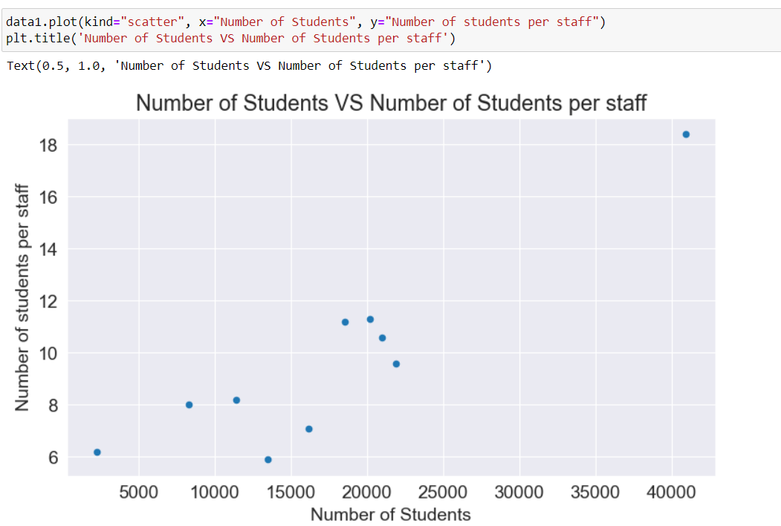

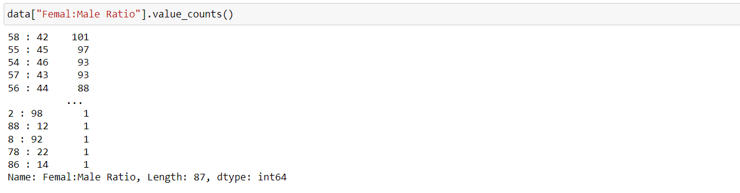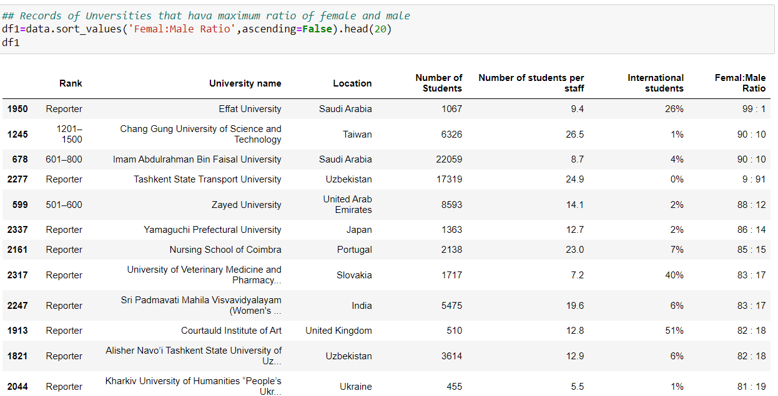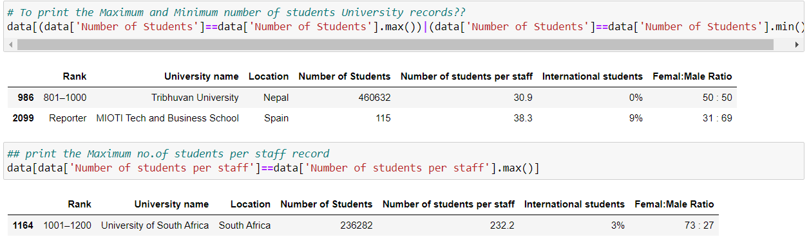

**RESULTS**

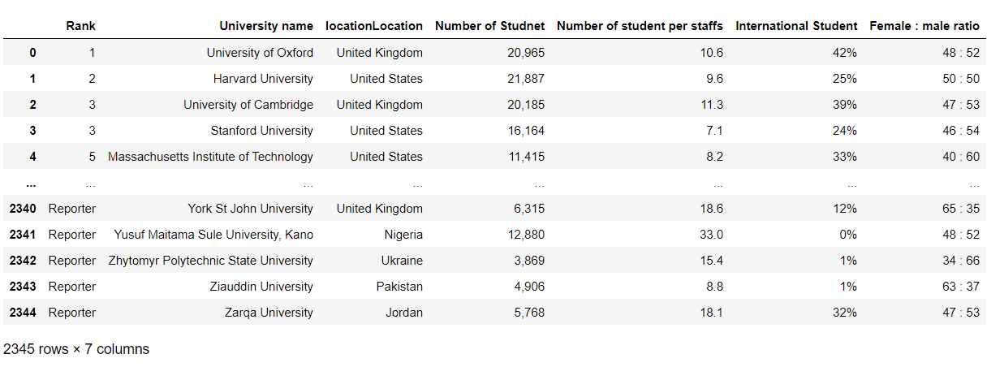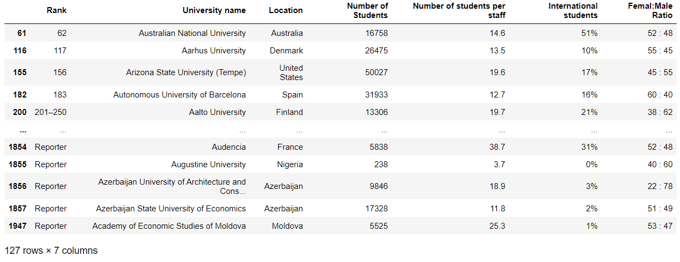

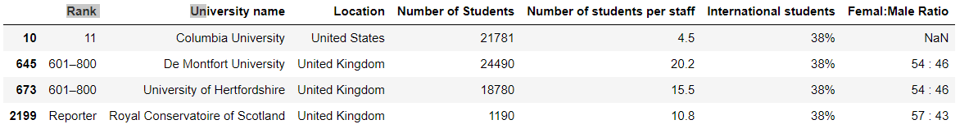

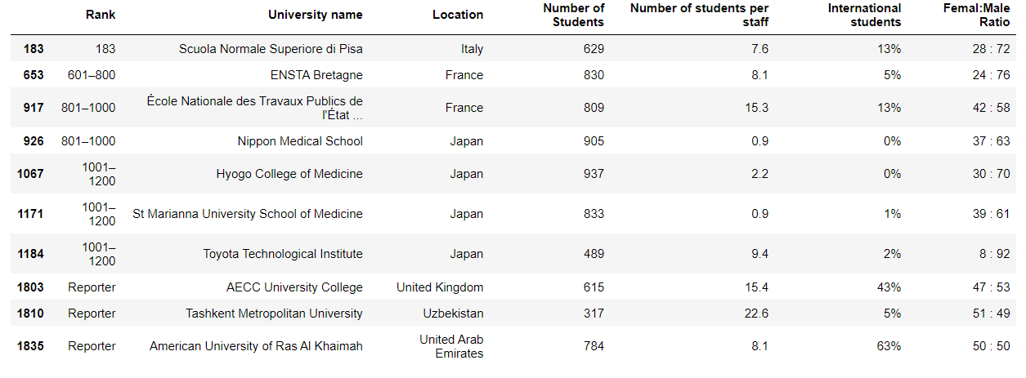

**Visualization**

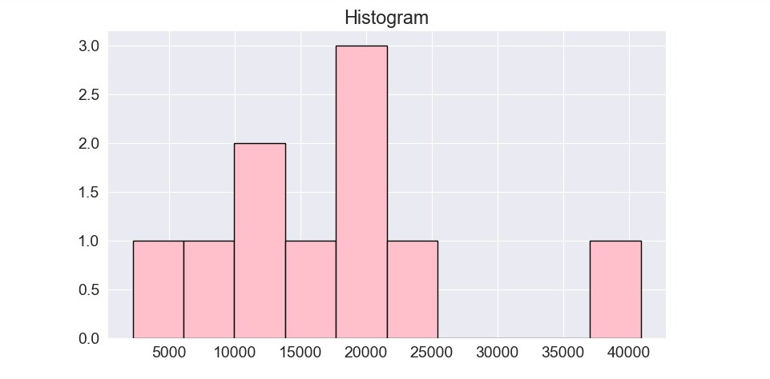

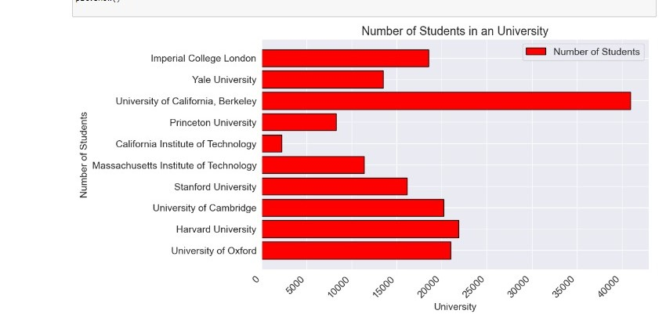

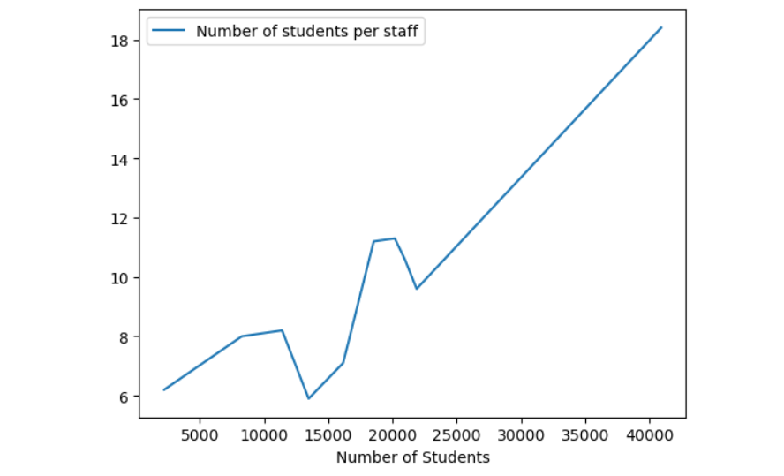

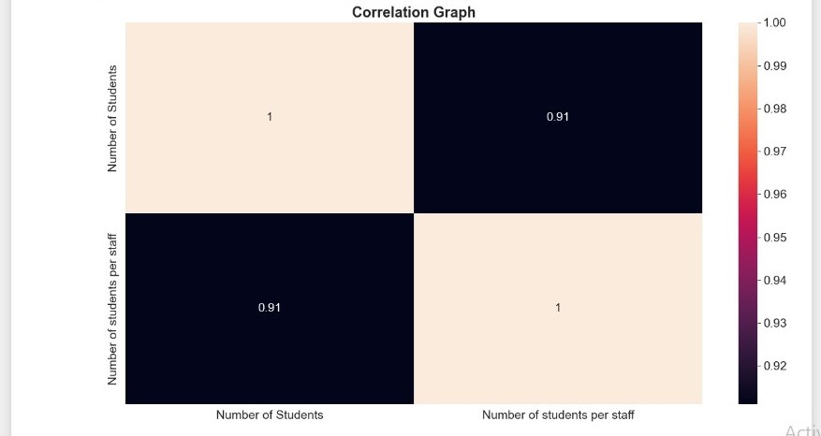

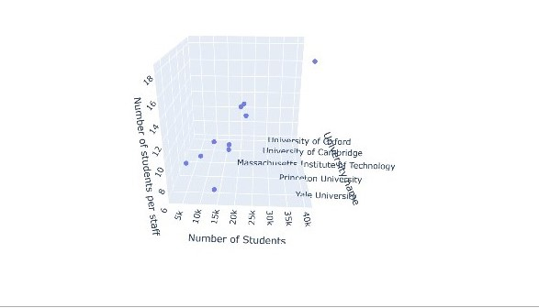

**Conclusion**

I have done very well in this internship. I have learnt very good skills which help us in doing projects and also in future. I have learnt a basic data analysis that boosts my confidence to learn more about data analysis and help to start my journey to learning data technologies using Python.

This type of project typically involves collecting and analyzing data related to the rankings that appear on University’s ranks section, which highlights universities that are currently popular and How the students are interested in joining those universities.

This project can help in finding, measuring, analysing and comparing key aspects of World Universities Rankings. It’s a great experience and I am very much satisfied by learning these skills.

References :

Kaggle

[www.Kaggle.com](http://www.kaggle.com)

YouTube

[www.YouTube.](http://www.youtube.com)